Face Recognition Assignment

GOAL:

Form a face recognition system and get hands-on experience writing machine learning algorithms as well as dimensionality reduction techniques, mainly PCA & LDA. : In implementing the algorithms we learn a method to be able to reduce high dimensional data which would require complex algorithms into lower dimensional data without significant loss of information Using these implementations to train a face recognition program

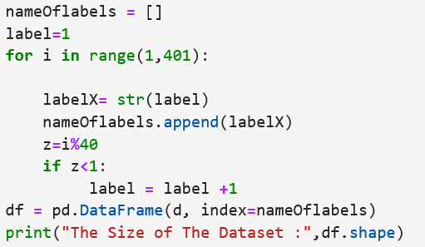Procedures:

1-We will use ATT dataset for this assignment.

2-Convert every image into a vector of 10304 values corresponding to the image size. b. Stack the 400 vector into a single Data Matrix D and generate the label vector y. The labels are integers from 1:40 corresponding to the subject id give every 40 rows an Id from 1 to 10

**3-Spliting the data to train and test Data 50% :50%**

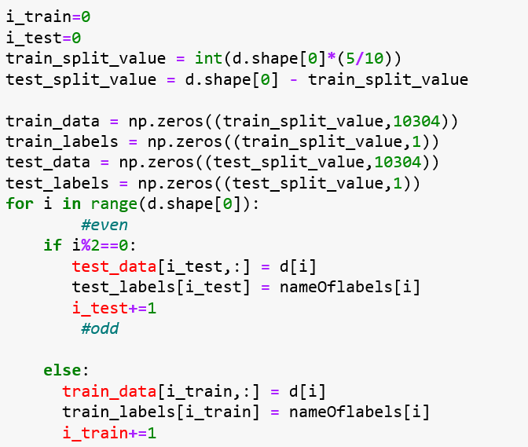

**For PCA**

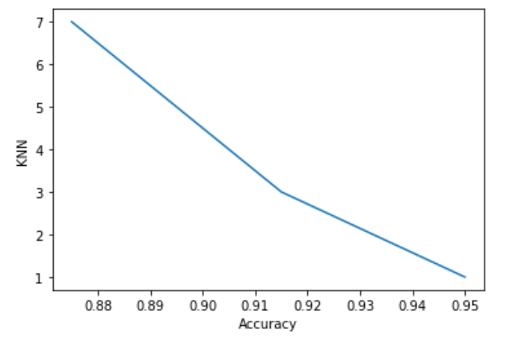After Calculating and saving the eigenvalues and eigenvectors we then allow anyone to slice from it as many features according to a certain threshold for covariance (alpha)

For the Bonus *Nature Dataset*

It was bad accuracy because the data note related to each of element

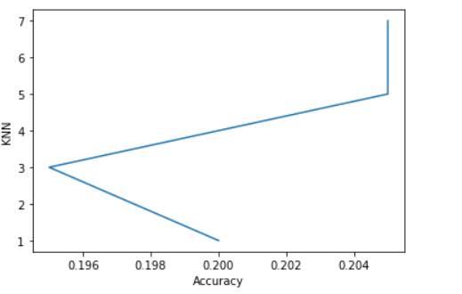

LDA

Since both algorithms serve no purpose but to lower the number of dimensions.. The new reduced projected data must be then passed to a suitable discriminator. Now that it is reduced we can use For the original problem: We use KNN classifier, as it would now be significantly less with the fewer features. We test the algorithm with different number of k: [1, 3, 5, 7]

